Rapid Risk Evaluation Tool

EARTHQUAKES MODULE

Software Requirements Specification

Version 2.0

Miroslav Nastev, Alex Smirnoff, Eric Boisvert, Héryk Julien, Nick Gibb, Heather McGrath, Ahmad Abo El Ezz, Marc-André Carrier, and Michel Parent

GSC–Quebec  
Natural Resources Canada



May 2018

# Table of contents

Table of contents i

List of tables iii

List of figures iv

Revision history v

1 Introduction 1

1.1 Purpose 1

1.2 Document conventions 1

1.3 Intended audience and reading suggestions 1

1.4 Project scope 1

2 Overall description 2

2.1 Product perspective 2

2.2 Product features 2

2.3 User classes and characteristics 3

2.4 Operating environment 3

2.5 Design and implementation constraints 3

2.6 User documentation 4

2.7 Assumptions and dependencies 4

2.7.1 Time dependencies 4

2.7.2 Hardware dependencies 4

2.7.3 External dependencies 4

3 System features 5

3.1 Landing page for hazard type selection 5

3.1.1 Description and priority 5

3.1.2 Use case(s) 5

3.1.3 Functional requirements 5

3.1.4 Activity diagram 6

3.2 Display map, navigation bar, and introductory dialog box 6

3.2.1 Description and priority 6

3.2.2 Use case(s) 6

3.2.3 Functional requirements 7

3.2.4 Activity diagram 7

3.3 Set earthquake epicenter 7

3.3.1 Description and priority 7

3.3.2 Use case(s) 7

3.3.3 Functional requirements 8

3.3.4 Activity diagram 8

3.4 Input magnitude and depth 8

3.4.1 Description and priority 8

3.4.2 Use case(s) 9

3.4.3 Functional requirements 9

3.4.4 Activity diagram 10

3.5 Execute risk assessment analysis 10

3.5.1 Description and priority 10

3.5.2 Use case(s) 10

3.5.3 Functional requirements 11

3.5.4 Activity diagram 11

3.6 Provide capability to access analysis results 11

3.6.1 Description and Priority 11

3.6.2 Use case(s) 11

3.6.3 Functional requirements 12

3.6.4 Activity diagram 13

3.7 Provide options to return to previous steps 13

3.7.1 Description and priority 13

3.7.2 Use case(s) 13

3.7.3 Functional requirements 14

3.7.4 Activity diagram 14

4 External interface requirements 15

4.1 User interfaces 15

4.1.1 Display info 15

4.1.2 Selecting hazard type 16

4.1.3 Displaying introductory screen 17

4.1.4 Selecting analysis type 17

4.1.5 Setting epicenter location 17

4.1.6 Inputting the magnitude and depth 18

4.1.7 Executing risk assessment analysis 19

4.1.8 Providing access to analysis results 21

4.1.9 Conduct multiple simulations 24

4.1.10 Re-open introduction dialog box 25

4.2 Hardware interfaces 25

4.3 Software interfaces 25

4.3.1 Incoming and outgoing items 25

4.3.2 Services and communication 26

4.4 Communications interfaces 26

5 Other nonfunctional requirements 27

5.1 Performance requirements 27

5.2 Safety requirements 27

5.3 Security requirements 27

5.4 Software quality attributes 27

6 Other requirements 28

6.1 Usability 28

6.2 Customization 28

Appendix A: Glossary 29

Appendix B: Flow diagram 30

Appendix C: Issues list 31

References 32

# List of tables

**Table 1.** Document revision history. v

**Table 2.** Features in the current version of the earthquake application. 3

**Table 3.** Relations between screen captures and associated features and use cases. 15

**Table 4.** List of issues. 31

# List of figures

**Figure 1.** Rapid Risk Evaluation Tool (ER2) within the context of risk-based planning. Modified from Journeay et al. (2015). 2

**Figure 2.** Welcome dialog box for the seismic risk analysis. The design of the application will be responsive to various devices. (a) The default display for a PC; (b) the default display for mobile devices and small tablets. 16

**Figure 3.** Landing page where the user selects the hazard type (note that the background image is temporary and subject to change, and the “flood,” “wildfire”, and “hurricane” components have not been developed). 17

**Figure 4.** (a)The user can select the epicenter location by navigating the map and single-clicking (note the crosshair cursor). (b) The user can also select the epicenter location by navigating the map and right-clicking, which opens the context menu. 18

**Figure 5.** A red marker is placed on the map to indicate the epicenter location. 18

**Figure 6.** Displaying the epicenter location and opening the “New Simulation” dialog box, where the user inputs the magnitude and depth. 19

**Figure 7.** A running simulation. Concentric red circles pulsate from the epicenter and a progress bar (top-left) displays the level of completion. 20

**Figure 8.** The “simulation complete” dialog box that notifies the user that the simulation is complete. 21

**Figure 9.** The layers (simulation results) can be accessed and displayed on the map through the “change layer” drop-up menu (map icon). 22

**Figure 10.** Simulation statistics can be opened by clicking the download icon. 22

**Figure 11.** Simulation statistics are currently displayed in a new window as a HTML table. 22

**Figure 12.** There are two ways to access statistics for individual census tracts: (a) by switching modes using the drop-up select; or (b) through the context-menu. 23

**Figure 13.** Census tract statistics open in a dialog box. The associated census tract is outlined in red. 24

**Figure 14.** Simulations are stored for later retrieval and display on the map. 25

**Figure 15.** Option to re-open the introduction dialog box. 25

# Revision history

**Table 1.** Document revision history.

|  |  |  |  |
| --- | --- | --- | --- |
| Name | Date | Reason For Changes | Version |
| Marc-André Carrier | 2015/09/10 | Initial draft of introductory sections | 1.0.0_draft_A |
| Marc-André Carrier | 2015/11/11 | Reviewed draft of introductory sections | 1.0.0_draft_B |
| Alex Smirnoff | 2015/11/12 | Revisions to Section 2.2 | 1.0.0_draft_C |
| Marc-André Carrier | 2015/11/27 | Reviewed draft of introductory sections | 1.0.0_draft_D |
| Nick Gibb | 2018/05/15 | Website has been substantially developed | 2.0.0 |

# Introduction

## Purpose

The purpose of this Software Requirements Specification (SRS) document is to provide a detailed description of features and functionalities of the “Rapid Risk Evaluation Tool (ER²)”, a web-based application designed for natural hazard risk assessment. Simplified screenshots of the current version of the application will also be provided.

## Document conventions

This document is printed on 8''×11'' paper with a 0.75'' top margin, 1'' bottom margin, and 1.6'' left and right margins. The fonts are Garamond (serif /font for body text) and Gill Sans MT (sans-serif font for headings, captions, and tables). Normal text is size 11 black, level one headings are bolded size 11 black in caps, level two headings are bolded size 10.5 black, and level three headings are size 10.5 black. Captions and tables are size 10 black.

## Intended audience and reading suggestions

This document is meant to be read by all members of the team working on this project, and by future end users, notably those from the public safety community, including risk and emergency managers.

The document is structured in the suggested reading order and may be read from the beginning to the end for a complete understanding of the project. However, it is written in sections and hence can be read as such. For a brief overview of the document and the project itself, see Section 2.

## Project scope

The objective of the project is to develop a web-based application that will allow local stakeholders of the public safety community to undertake mitigation planning by evaluating potential physical damage states as well as economic and social losses resulting from natural hazards. The initial version of the application, “Rapid Risk Evaluation Tool (ER²)”, will use a simple interface with out-of-the-box capacity and will allow risk assessment from flood and earthquake hazard scenarios. This documentation covers the earthquake module only.

Benefits will include web-based access to a simple but efficient tool for first-order risk assessment. The application will use a graphical user interface (GUI) with reference background maps and will be flexible in terms of inputs required from the users. Options for user provided data or default parameters will be available.

# Overall description

## Product perspective

This product will be a part of the Quantitative Risk Assessments Project triggered by the *Emergency Management Act* ([laws-lois.justice.gc.ca/eng/acts/E-4.56](http://laws-lois.justice.gc.ca/eng/acts/E-4.56/page-1.html%23h-1)). The project is aimed at developing standardized methods and tools for risk assessment and promoting their understanding, acceptance, and widespread usage among the full range of Canadian decision-makers.

Most risk and emergency managers in Canada are currently lacking the necessary tools and guidance to adequately undertake rigorous risk assessments with regards to natural hazards. While numerous computer models exist for natural hazard risk assessment, they usually require advanced knowledge of geographic information systems (GIS) and intensive data preparation and processing — e.g. OpenQuake (GEM, 2015), HAZUS-MH (FEMA 2012), and CAPRA (ERN-AL 2015). The purpose of the project is therefore to provide a user-friendly rapid risk assessment tool to allow non-expert users from the Canadian public safety community to run otherwise complex risk scenarios at a “click of a button”.

The Rapid Risk Evaluation Tool (ER²) will be an interactive, web-based application. It will allow risk assessment to be performed with minimal input from users; however it will also offer the possibility to take advantage of local and/or more detailed input data. The context encompassing the risk evaluation process targeted by ER2 is presented in Figure 1, while the key algorithms and methodology are presented by Smirnoff et al. (2015) and Nastev et al. (2015).

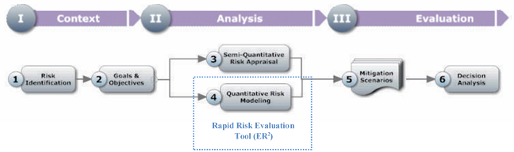

**Figure 1.** Rapid Risk Evaluation Tool (ER2) within the context of risk-based planning. Modified from Journeay et al. (2015).

## Product features

The current application provides many options and capabilities (Table 2). To show how these functionalities are related, a flow diagram is provided in Appendix B. Note that additional functionalities may be added with future releases.

**Table 2.** Features in the current version of the earthquake application.

|  |  |  |
| --- | --- | --- |
| ID | Description | |
| F1 | Option to select natural hazard type | |
| F2 | Capability to display introductory screen with general information | |
| F3 | Capability to define earthquake epicenter on the map | |
| F4 | Capability to display location of selected epicenter | |
| F5 | Capability to specify earthquake magnitude and depth | |
| F6 | Capability to display the magnitude, depth, and coordinates of the selected earthquake | |
| F7 | Offer options to run the analysis (F8) or cancel analysis and redefine earthquake epicenter location and/or magnitude (F3, F5) | |
| F8 | Capability to execute analysis with the selected scenario | |
| F9 | Capability to access the results of analysis: | |
| F9.1 | | Capability to view results on map |
| F9.2 | | Capability to view summary report |
| F9.3 | | Capability to download summary report |
| F9.4 | | Capability to query by census tract |
| F10 | Able to return to one of the previous steps: | |
| F10.1 | | Analysis results (F9) |
| F10.2 | | Scenario definition (F3) |
| F10.3 | | Introductory screen (F2) |

## User classes and characteristics

The target user class of this system includes stakeholders from the public safety community, particularly emergency planners, land use planners, and decision makers (e.g. policy, insurance, etc.) However, other users such as civil engineers and geoscientists could be a part of the user community as customized analysis features become available.

The tool is intended for non-expert users and as such will not require advanced skills. However, basic knowledge of the input data necessary for natural hazard risk analyses will be required. Some users may prefer to read the documentation prior to attempting analyses.

## Operating environment

The application currently executes on the two most popular web browsers, Mozilla Firefox and Google Chrome. It is functional on both PC and mobile devices. Internet Explorer and Safari functionality will be added at a later date.

## Design and implementation constraints

None.

## User documentation

User documentation with examples will be provided online. Instructions will also be included in the interface (e.g. dialog boxes and tooltips).

## Assumptions and dependencies

### Time dependencies

The core features of the application are provided in Table 2. These features are crucial for the basic functionality of the application and have already been implemented. In the future, additional features may be added to enhance the application.

### Hardware dependencies

None.

### External dependencies

None.

# System features

## Landing page for hazard type selection

### Description and priority

An initial landing page prompts the user to select the hazard type.

### Use case(s)

Use case name and identifier: UC1 — Landing page

Objective: The user selects the hazard type

Priority: High

Source: User

Actors: User, Application

Preconditions:

User navigates to application URL

Post-conditions:

UC2 — Display map base layers, navigation bar, and introductory dialog box

Flow of events:

1. SYSTEM (F1): Displays landing page with “seismic” and “flood” buttons
2. USER: Presses preferred hazard button

Special requirements: None

Notes: None

### Functional requirements

UC1.FR1: Upon entering the application URL, the system shall display the landing page.

UC1.FR2: Upon pressing a button (i.e. “earthquakes”), the system shall navigate to the associated URL.

### Activity diagram

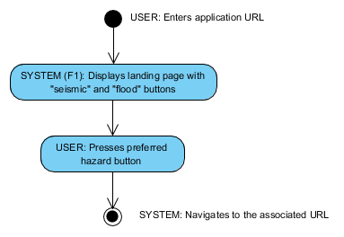

## Display map, navigation bar, and introductory dialog box

### Description and priority

Upon navigating to the seismic analysis webpage, the user is presented with a dialog box containing information about the application.

### Use case(s)

Use case name and identifier: UC2 — Display map base layers, navigation bar, and introductory dialog box

Objective: Upon entering the screen, the system shall display: (1) the map centered on Canada with the census tracts drawn; and (2) a bottom navigation bar with buttons for zoom control and drop-up menus for changing layers and toggling modes (“set epicenter” and “query census tract”).

Priority: High

Source: User

Actors: User, Application

Preconditions:

UC1 — Display landing page with hazard type selection

User presses seismic hazard button in UC1

Post-conditions:

UC3 — Set earthquake epicenter

Flow of events:

1. SYSTEM (F2): Displays a dialog box with important information about the application. In the background, displays the map (with census tracts drawn) and the navigation bar.
2. USER: Closes the dialog box
3. SYSTEM: Hides dialog box

Special requirements: None

Notes: None

### Functional requirements

The system displays a dialog box in the foreground, and in the background the navigation bar and a map centered on Canada.

### Activity diagram

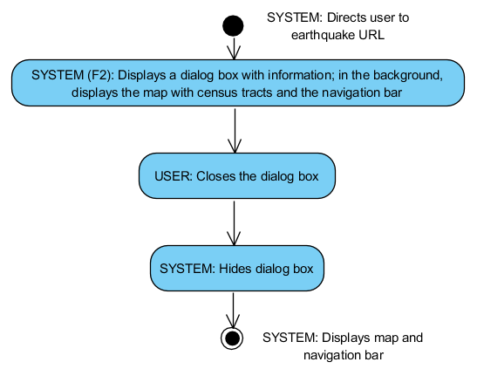

## Set earthquake epicenter

### Description and priority

The user must set the epicenter location for the earthquake (i.e. the center point of the study region). To do so, the user navigates the map and clicks once on the desired location. A 50 km radius area (adjusted to census tract limits) will be generated automatically around the point.

### Use case(s)

Use case name and identifier: UC3 — Set earthquake epicenter

Objective: The user sets the epicenter location to create a new study region

Priority: High

Source: User

Actors: User, Application

Preconditions:

UC2 — Display map base layers, navigation bar, and introductory dialog box.

Post-conditions:

UC4 — User inputs magnitude and depth and presses the “Run” button

Flow of Events:

1. USER (F3): Navigates map and sets epicenter location by single-clicking the map
2. SYSTEM (F4): Displays selected epicenter location on map

Special Requirements: None

Notes: None

### Functional requirements

UC3.FR1: The system shall allow the user to pan to a region (e.g. for PC users, by clicking and dragging the mouse or by using the keyboard arrow keys).

UC3.FR2: The system shall allow the user to zoom in or out on a region using the zoom buttons, the mouse scroll, the plus and minus keys on the keyboard, or (for mobile users) the pinch in/out gesture.

UC3.FR3: The system shall allow the user to select the epicenter location by single-clicking on the map.

UC3.FR4: Once the epicenter location has been set, the system shall display the selected epicenter location on the map.

### Activity diagram

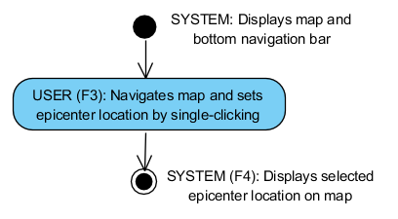

## Input magnitude and depth

### Description and priority

The user must input the seismic hazard magnitude and depth in order to perform the risk assessment. The application supports magnitudes from 5 to 8 and depths from 0 to 100 km. Then the user most choose to run the risk assessment or to cancel and redefine the earthquake epicenter location.

### Use case(s)

Use case name and identifier: UC4 — User inputs magnitude and depth and presses the “Run” button

Objective: The user inputs the earthquake magnitude and depth and chooses whether to run the simulation or to cancel.

Priority: High

Source: User

Actors: User, Application

Preconditions:

UC3 — Set epicenter for default seismic analysis

Post-conditions:

UC5 — Execute risk assessment analysis

Flow of Events:

1. SYSTEM: Displays dialog box containing select menu for magnitude and depth
2. USER (F5): Selects magnitude and depth
3. USER: Presses “Run” or “Cancel”
4. If USER: Presses “Cancel” button
   1. SYSTEM Displays/returns to “Set earthquake epicenter” screen
   2. UC3 — Set earthquake epicenter
5. End if

Special Requirements: None

Notes: None

### Functional requirements

UC4.FR1: The system shall display a dialog box with a select menu for magnitude (5.0–8.0 in 0.5 increments) and depth (0–100 km in 5 km increments), the coordinates of the epicenter, and buttons for “Cancel” and “Run”.

UC4.FR2: The system shall display a dialog box with “Run” and “Cancel” buttons providing options to proceed with analysis or exit to UC1.

UC4.FR3: When the user clicks the “Cancel” button, the system removes the epicenter marker and allows the user to start over (set epicenter — UC1).

UC4.FR4: When the user clicks the “Run” button, the system shall proceed with the analysis.

### Activity diagram

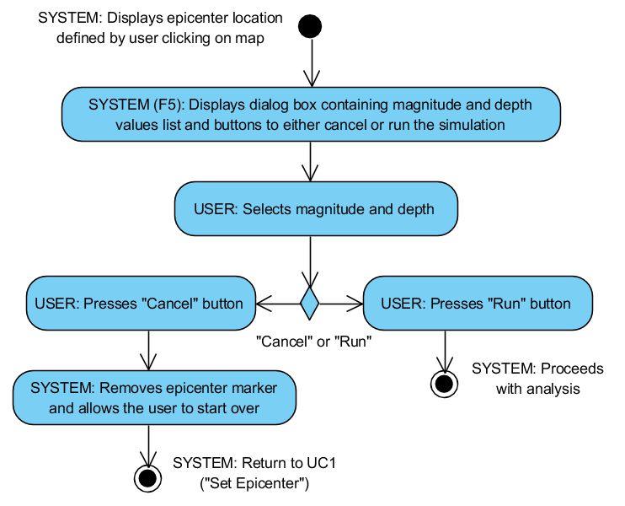

## Execute risk assessment analysis

### Description and priority

The application executes the analysis according to the input data provided.

### Use case(s)

Use case name and identifier: UC5 — Execute risk assessment analysis

Objective: The system executes the risk assessment analysis

Priority: High

Source: User

Actors: User, Application

Preconditions:

UC4 — User inputs magnitude and depth and presses the “Run” button

The system shall display a map with census tracts and a marker at the selected epicenter

Post-conditions:

UC6 — Provide capability to access analysis results

Flow of Events:

1. SYSTEM: Displays progress bar showing level of completion of analysis
2. SYSTEM: Displays dialog box to alert the user when the analysis is complete

Special Requirements: None

Notes: None

### Functional requirements

UC5.FR1: The system shall perform the risk assessment analysis for the selected scenario and display a progress bar to indicate the level of completion

### Activity diagram

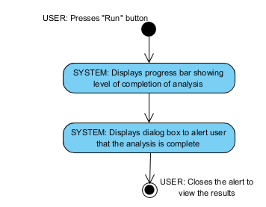

## Provide capability to access analysis results

### Description and Priority

Following completion of the analysis, the user can view results on the map and view or download a summary report. A list of the result layers are given in the “change layer” drop-up menu, allowing the user to toggle layer visibility on the map. Simulation results can be viewed or downloaded by clicking the download icon in the same drop-up menu, or by opening the context menu. Census tracts can be queried by accessing the “toggle modes” drop-up, or through the context menu.

### Use case(s)

Use case name and identifier: UC6 — Provide capability to access analysis results

Objective: The user views or downloads the results of analysis (for the entire simulation or for select census tracts)

Priority: High

Source: User

Actors: User, Application

Preconditions:

UC5 — Execute risk assessment analysis

The system shall display a map showing the census tracts, epicenter marker, and the hazard intensity results in transparency (with the corresponding legend)

Post-conditions:

UC7 — Provide options to return to previous steps

Flow of Events:

1. SYSTEM (F9): Displays map and bottom navigation bar with a drop-up menu allowing the user to toggle the visibility of the result layers and view and download the summary report
2. If USER: Clicks on a different result layer
   1. SYSTEM (F9.1): Displays the specified layer
3. If User: Queries a census tract
   1. SYSTEM (9.4): Shows census tract statistics in a dialog box
4. Else if USER: Clicks on “Open summary report” icon
   1. SYSTEM (F9.2): Opens the summary report in new browser window
   2. If USER: Clicks on “Download summary report” button
      1. SYSTEM (F9.3): Displays download location browser
      2. USER: Selects file location and file name
5. End if

Special Requirements: None

Notes: None

### Functional requirements

UC6.FR1: After the simulation has completed, the system shall populate the navigation bar drop-up menus with the different results (layers) and options to view and download the summary report.

UC6.FR2: When the user toggles on a different result layer, the system shall turn its visibility on (and all others layers off).

UC6.FR3: When the user selects the “Open summary report” icon, the system shall display the summary report in a new browser window.

UC6.FR4: When the user selects the “Download summary report” option, the system shall open the file location browser.

### Activity diagram

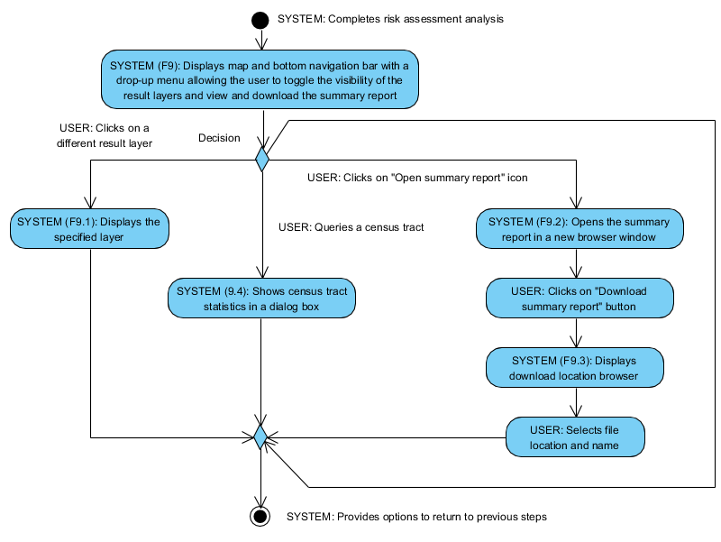

## Provide options to return to previous steps

### Description and priority

The user can choose to return to one of the previous steps: the Introductory screen (F2), the definition of the earthquake epicenter location and/or magnitude (F3) or the access to analysis results (F9).

### Use case(s)

Use case name and identifier: UC7 — Provide options to return to previous steps

Objective: The user chooses to continue viewing/downloading results (F9) or to go back to scenario definition (F3) or Introductory screen (F2).

Priority: High

Source: User

Actors: User, Application

Preconditions:

UC7 — Provide capability to access analysis results

Post-conditions: N/A

Flow of Events:

1. If USER: Single-clicks on the map
   1. SYSTEM: Displays “New Simulation” dialog box
   2. UC3 — Set earthquake epicenter
2. Else if USER: Clicks on a previous simulation in the dropdown menu
   1. SYSTEM: Loads the results from the specified simulation
3. Else if USER: Clicks on “Information” icon
   1. SYSTEM (F10.3): Displays the introductory screen
   2. UC2 — Display map base layers, navigation bar, and introductory dialog box
4. End if

Special Requirements: None

Notes: None

### Functional requirements

UC7.FR1: The system shall display a toolbar with tools allowing user to return to previous steps in the analysis (UC1 and UC1)

UC7.FR2: When the user clicks the map (UC3), the system shall display the “New Simulation” dialog box (UC4) to allow user define a new scenario.

UC7.FR3: When the user clicks the “About” button, the system shall display the “Introductory screen” (UC2) to allow user to review the provided information.

### Activity diagram

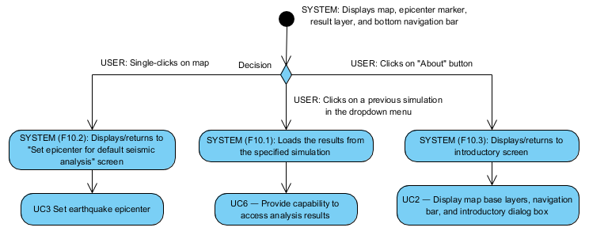

# External interface requirements

## User interfaces

In this section, screen captures of the features given in section 2.2 are presented. Table 3 summarizes the relations between these screenshot and each of the associated features and use cases.

**Table 3.** Relations between screen captures and associated features and use cases.

| feature ID | use case ID | screen capture |
| --- | --- | --- |
| F1 | UC1 | Figure 3 |
| F2 | UC2 | Figure 2 |
| F3 | UC3 | Figure 4 |
| F4 | Figure 5 |
| F5 | UC4 | Figure 6 |
| F6 |
| F7 |
| F8 | UC5 | Figure 7 |
| F9.1 | UC6 | Figure 8, Figure 9 |
| F9.2 | Figure 10, Figure 11 |
| F9.3 |
| F9.4 | Figure 12, Figure 13 |
| F10.1 | UC7 | Figure 14 |
| F10.2 | Figure 4, Figure 5 |
| F10.3 | Figure 15 |

### Display info

The application has three main elements — the map, dialog box, and bottom navigation bar. The application covers the entire browser window (Figure 2) and is responsive to different screen sizes. For instance, on mobile devices and small tablets (screen width less than 992 px), the zoom control buttons are not displayed, and the dialog boxes are reduced to an appropriate size (Figure 2b).

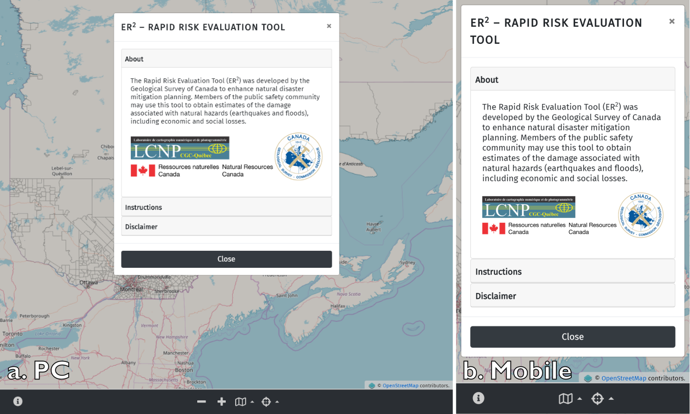

**Figure 2.** Welcome dialog box for the seismic risk analysis. The design of the application will be responsive to various devices. (a) The default display for a PC; (b) the default display for mobile devices and small tablets.

Fira Sans is the primary font (<https://fonts.google.com/specimen/Fira+Sans>). If Fira Sans is unavailable, a common sans-serif font is used (e.g. Arial). The font size font varies depending on the element being displayed and the screen resolution.

### Selecting hazard type

The user navigates to the landing page URL and chooses “Earthquakes” as the hazard type (Figure 3). When the button is clicked, the corresponding URL is opened in a new browser window.

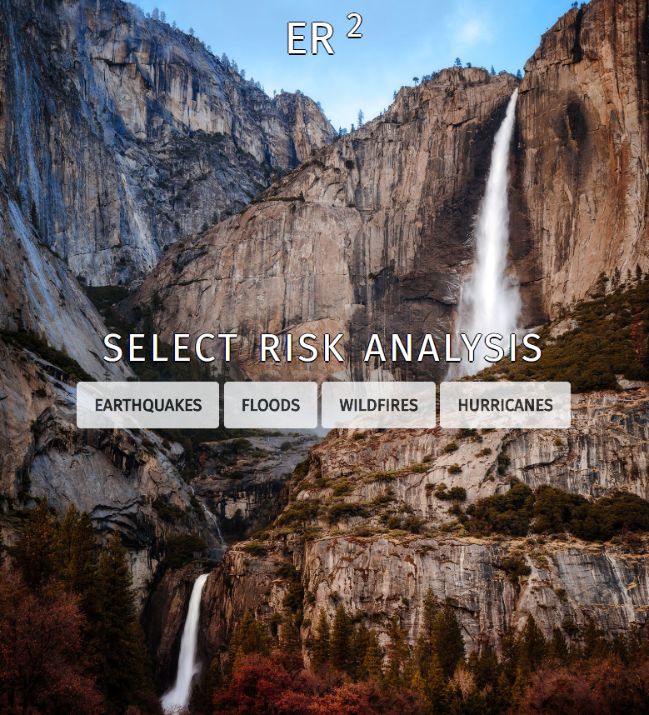

**Figure 3.** Landing page where the user selects the hazard type (note that the background image is temporary and subject to change, and the “flood,” “wildfire”, and “hurricane” components have not been developed).

### Displaying introductory screen

The user is presented with a dialog box in the foreground and a dimmed map in the background (Figure 2). The dialog box contains general information, instructions, and a disclaimer. The user must click on the “Close” button to proceed.

### Selecting analysis type

In the current version, only the default seismic analysis is available. With future updates, the user will be able to conduct a custom analysis by clicking a button located on the bottom navigation bar. A short explanation of the two analyses will be added to the instructions in the welcome dialog box (Figure 2).

### Setting epicenter location

The user must set the point location representing the epicenter. The application will place a marker on the map at this location.

#### Setting and displaying the epicenter location

For the default seismic hazard analysis, the first step is to set the point location representing the epicenter. To do so, the user must pan/zoom to their desired location and then either:

1. Single-click at the desired epicenter location (Figure 4a).
2. Right-click at the desired epicenter location, and then select “New simulation” in the context menu (Figure 4b). Initially there is only one item in the context menu — “New simulation”.

With either method, a red marker is placed on the map to designate the epicenter (Figure 5). The study region will correspond to a 50 km radius around the epicenter location, adjusted to census tract limits.

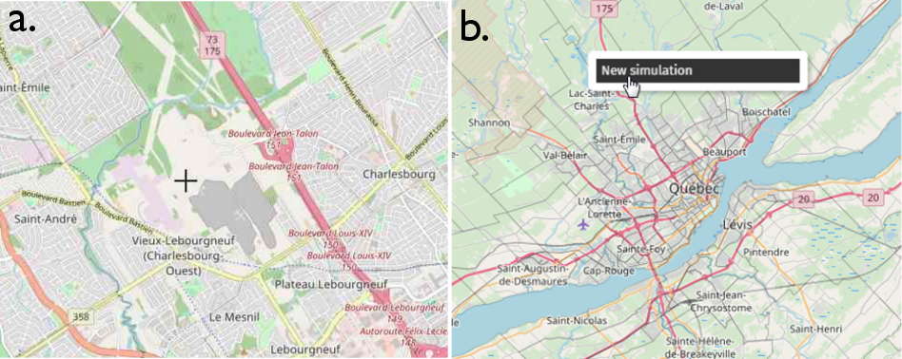

**Figure 4.** (a)The user can select the epicenter location by navigating the map and single-clicking (note the crosshair cursor). (b) The user can also select the epicenter location by navigating the map and right-clicking, which opens the context menu.

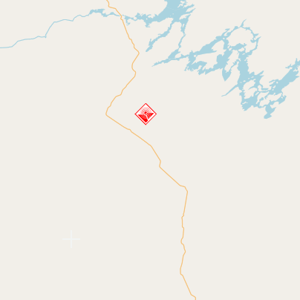

**Figure 5.** A red marker is placed on the map to indicate the epicenter location.

### Inputting the magnitude and depth

After the epicenter location is set, the “New Simulation” dialog box appears for the user to input the magnitude and depth of the seismic hazard (Figure 6). The coordinates and projection system are also displayed for informational purposes only (cannot be modified). The user can then press “Run” to initiate the simulation, or “Cancel” if a different epicenter location is desired.

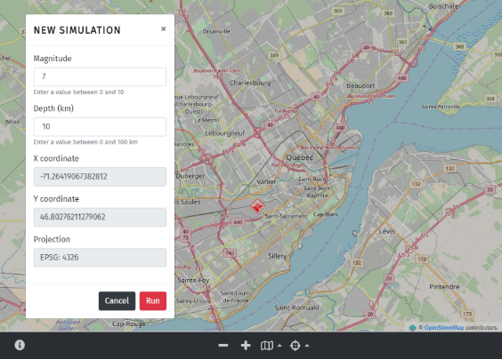

**Figure 6.** Displaying the epicenter location and opening the “New Simulation” dialog box, where the user inputs the magnitude and depth.

### Executing risk assessment analysis

After clicking “Run”, the calculations begin and a progress bar appears to show the level of completion (Figure 7). Concentric red circles also pulsate from the epicenter location while the calculations are running.

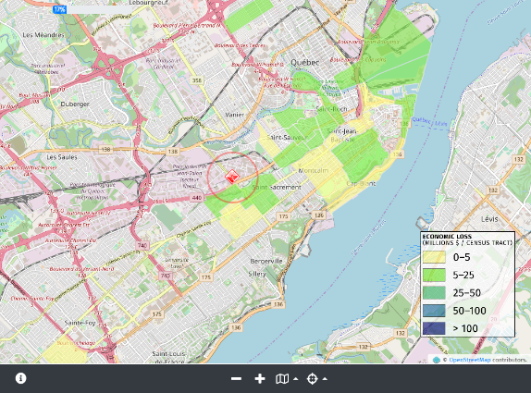

**Figure 7.** A running simulation. Concentric red circles pulsate from the epicenter and a progress bar (top-left) displays the level of completion.

A dialog box notifies the user when the analysis is completed (Figure 8). Total economic loss is displayed initially by default, but the user can toggle between different layers (section 4.1.8).

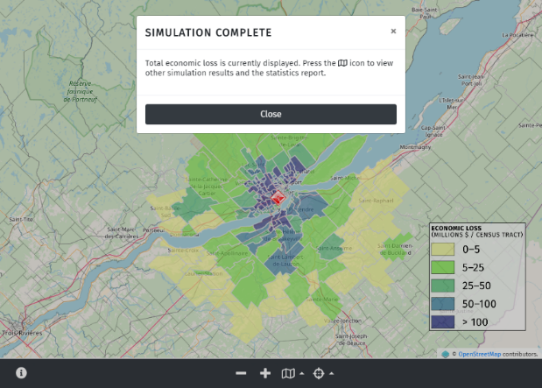

**Figure 8.** The “simulation complete” dialog box that notifies the user that the simulation is complete.

### Providing access to analysis results

After a risk analysis has been conducted, the user can change the displayed map layers (i.e. view different simulation results), view and download simulation statistics, and view statistics by individual census tracts. These three functionalities are detailed below.

#### View analysis results on map

By accessing the “change layer” drop-up menu (map icon on the navigation bar), the application will display the layer (or result) list (Figure 9). The user can change the layer that is displayed on the map. The legend will automatically update to correspond to the active layer.

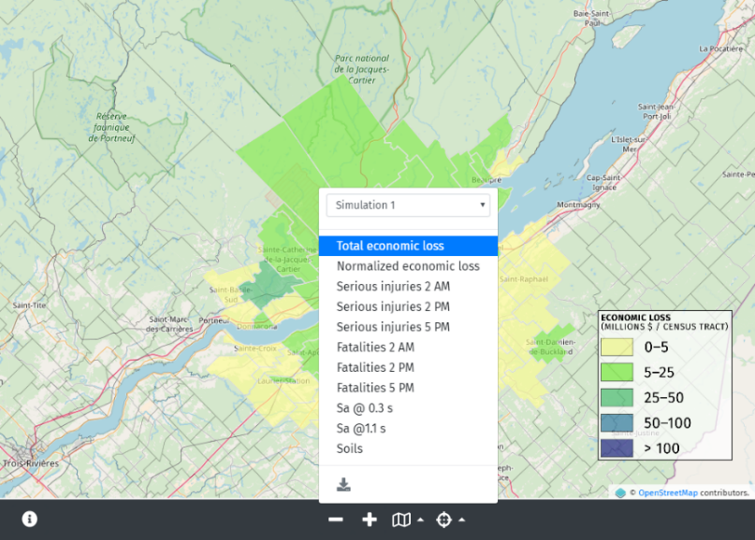

**Figure 9.** The layers (simulation results) can be accessed and displayed on the map through the “change layer” drop-up menu (map icon).

#### View and download simulation statistics

If the user presses the “Open simulation statistics” button (located in the map drop-up menu; Figure 10), the application will open the summary report. Currently, this report opens in a new browser window (Figure 11), but in a future version it will open as a dialog box (similar to Figure 13).

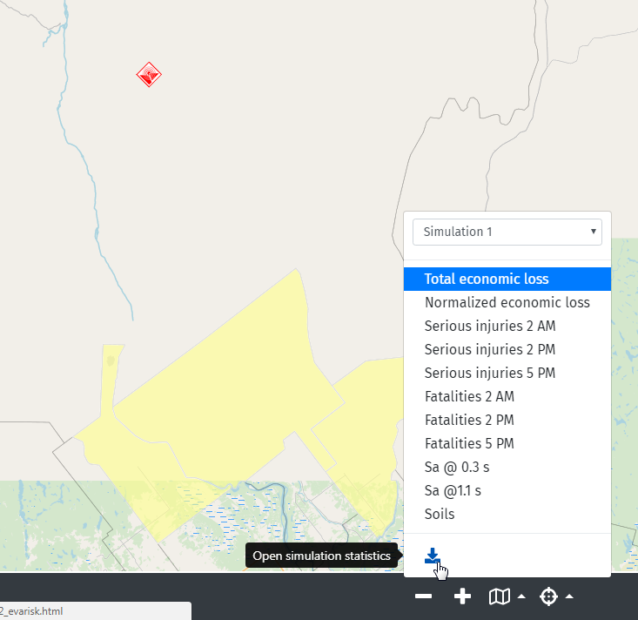

**Figure 10.** Simulation statistics can be opened by clicking the download icon.

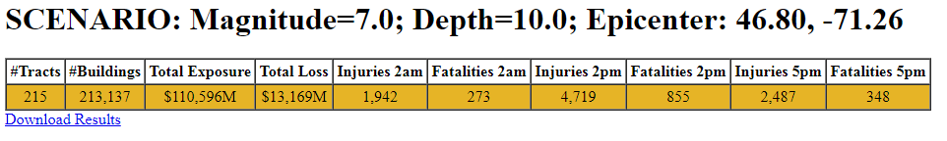

**Figure 11.** Simulation statistics are currently displayed in a new window as a HTML table.

#### View statistics by census tract

The application can provide detailed information for each affected census tract. There are two ways for the user to view tract statistics:

1. In the “toggle modes” drop-up menu, switch to “Select census tract” (Figure 12a). The cursor will change from crosshair to help. The user can then single click on a specific census tract.
2. Right-click on the census tract, and then select “Census tract statistics” in the context menu (Figure 12b).

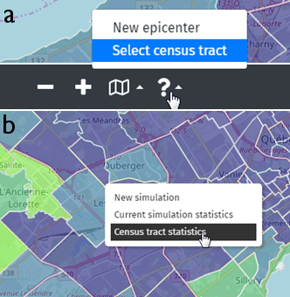

**Figure 12.** There are two ways to access statistics for individual census tracts: (a) by switching modes using the drop-up select; or (b) through the context-menu.

The census tract statistics open in a dialog box that does not obscure the selected tract (outlined in red) from view (Figure 13).

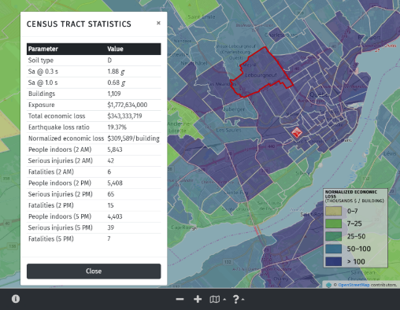

**Figure 13.** Census tract statistics open in a dialog box. The associated census tract is outlined in red.

### Conduct multiple simulations

The user may conduct additional simulations by following the same steps detailed in Section 4.1.5. The layers resulting from these additional scenarios are stored and managed by the application. They can be retrieved and loaded through the “change layers” drop-up menu (Figure 14).

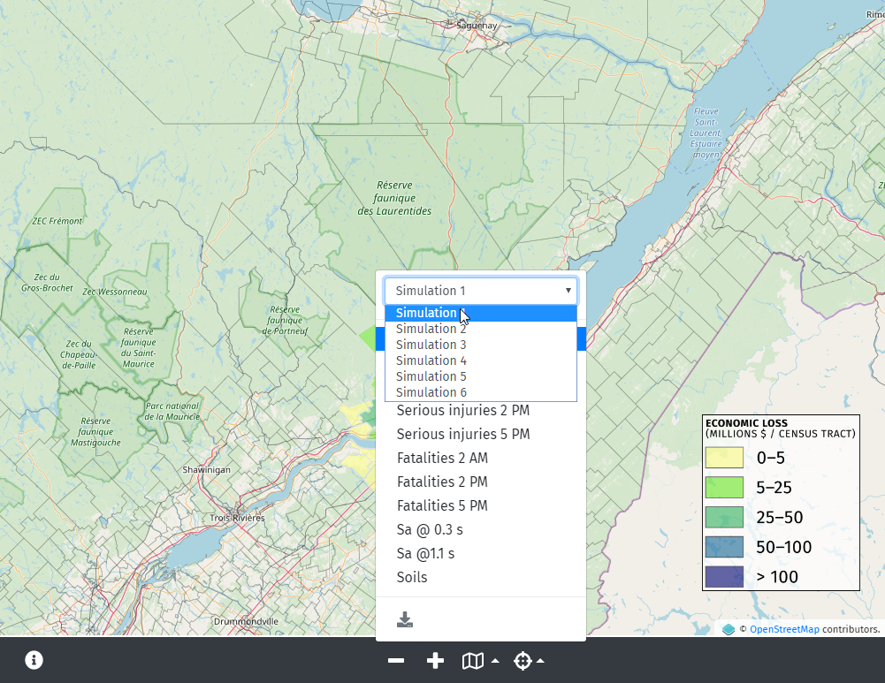

**Figure 14.** Simulations are stored for later retrieval and display on the map.

### Re-open introduction dialog box

The user may want to review the content provided in the introduction dialog box. This dialog box can be re-opened by clicking the information icon located at the bottom left (Figure 15).



**Figure 15.** Option to re-open the introduction dialog box.

## Hardware interfaces

The system is intended as a web-based application for major web browsers (i.e. Mozilla Firefox and Google Chrome). Application data is stored on a dedicated server for the basic functionalities of the first version of the application. Future releases will offer the possibility to download data and results from the server to a standard desktop or laptop system.

## Software interfaces

### Incoming and outgoing items

Incoming data will include default exposure database as well as a database with pre-calculated vulnerability curves for seismic hazard analysis.

Outgoing data with include analysis results and summary report generated from these results.

### Services and communication

The application will require access to WMS services to display the basemap and the result layers.

## Communications interfaces

As a web-based application, the system will function through web browsers and will have to communicate with data servers to perform risk analysis.

# Other nonfunctional requirements

## Performance requirements

The application performance should be evaluated against the following major criteria:

* time required to perform risk assessment analysis
* quick and efficient access to and navigation between screens (no noticeable delay)
* no system freeze at any time

## Safety requirements

The system must not

* cause problems to the operating system
* cause problems or damage to device hardware (e.g. overheating)

## Security requirements

The application must meet the requirements specified in the Cyber Security Action Plan based on the documents published by the Open Web Application Security Project (OWASP 2018){(OWASP),É#4} {(OWASP), 2018 #4}{(OWASP), 2018 #4} {, 2018 #4}.

## Software quality attributes

The design of the graphical user interface is intended to be intuitive. The presentation and organization of the application is visually appealing and easy for the user to navigate. Instructions are provided at the beginning, and tooltips are included to indicate the functionalities of different buttons. If there are any errors, the user is notified with an alert message. All this provides convenience of operation and shortens the learning curve for new users.

# Other requirements

## Usability

Some of the application features and workflows have been designed based on existing risk assessment software in order to provide a more logical flow for the user.

## Customization

For more advanced users, custom features may be implemented in future releases of the application.

# Appendix A: Glossary

|  |  |
| --- | --- |
| Aggregated building data | Data on all available building types, aggregated at the centroid of each census tract |
| Building specific data | Data on individual buildings at specific locations (user-defined) |
| Default exposure data | Default exposure data corresponds to the aggregated building data inventory and/or essential facility inventory according to the application requirements |
| GUI | Graphical User Interface |
| Hazard sub-type | Type of seismic or flood hazard (e.g. deterministic, probabilistic, user-refined) |
| Hazard type | Type of hazard selected for risk assessment (e.g.: seismic or flood) |
| Site-specific data | Data on facilities that provide services to the community and should be functional after a hazard (i.e. essential facilities such as hospitals, fire stations) |
| SRS | Software Requirements Specification |
| WMS | Web Map Service |

# 

# Appendix B: Flow diagram

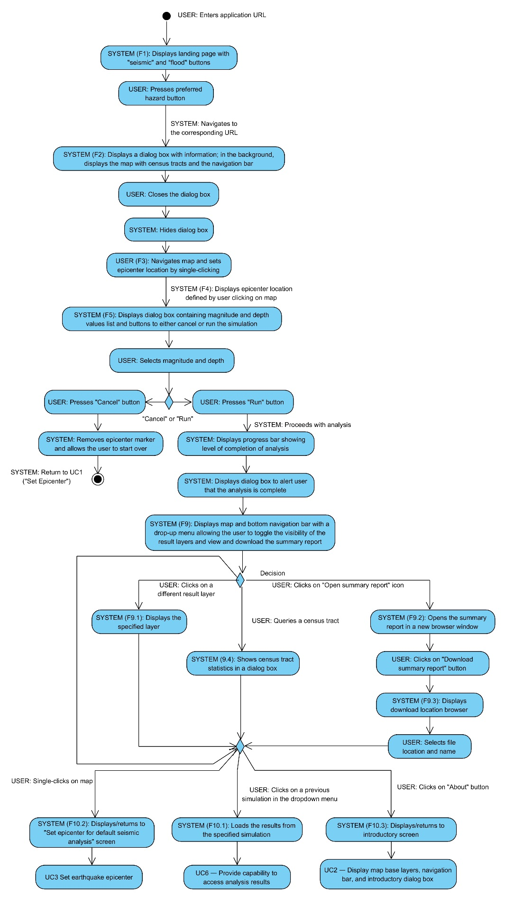

# Appendix C: Issues list

**Table 4.** List of issues.

|  |  |  |  |
| --- | --- | --- | --- |
| Issue ID | Description | Owner | Due Date |
|  | Potential user feedback is required to refine and review the workflows for custom analyses. |  |  |

# References

Journeay, J. M., F. Dercole, D. Mason, M. Westin, J. A. Prieto, C. L. Wagner, N. L. Hastings, S. E. Chang, A. Lotze & C. E. Ventura (2015) A profile of earthquake risk for the district of North Vancouver, British Columbia. Geological Survey of Canada, Open File, 7677.

Nastev, M., M.-J. Nollet, A. Abo El Ezz, A. Smirnoff, S. K. Ploeger, H. McGrath, M. Sawada, E. Stefanakis & M. Parent (2015) Methods and tools for natural hazard risk analysis in eastern Canada: Using knowledge to understand vulnerability and implement mitigation measures. Natural Hazards Review, 18, B4015002.

Open Web Application Security Project (OWASP). 2018. https://www.owasp.org

Smirnoff, A., A. Abo El Ezz, M. Nollet & M. Nastev. 2015. Towards a Rapid Seismic Risk Assessment Tool for Canada. In The 11th Canadian Conference on Earthquake Engineering. Victoria, Canada.